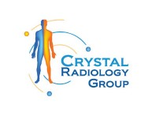What You Need to Know Before Getting a Full-Body CT Scan at Crystal Radiology. (02) 8315 8292

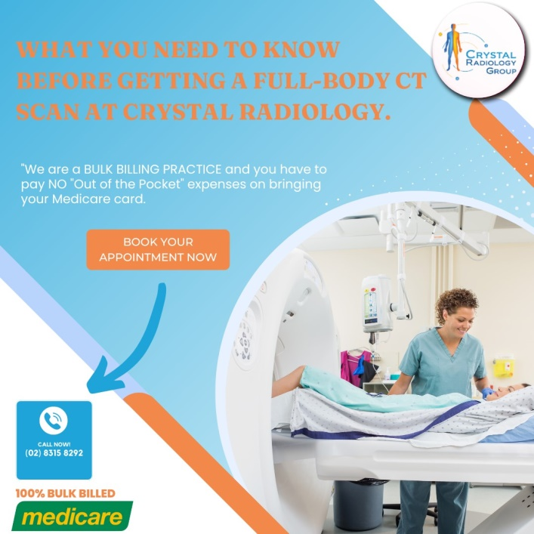A whole-body CT scan, also known as a computed tomography (CT) or CAT scan, is a comprehensive imaging technique used to visualize the internal structures of your body, including tissues, organs, and bones. This powerful screening test is particularly useful in providing detailed images of the chest, abdomen, and pelvis.

At Crystal Radiology, our goal is to offer high-quality diagnostic imaging services that cater to a wide range of medical conditions. Whether you need a [CT scan](https://crystalradiology.com.au/ct-scan/) for routine screening or to investigate specific health concerns, here’s what you should know before getting a full-body CT scan.

## What is a Full-Body CT Scan?

A full-body CT scan is a non-invasive imaging test that produces cross-sectional images of your entire body using X-ray technology. The images are processed by sophisticated software that allows doctors to view detailed internal structures from various angles. These scans can be viewed on digital devices, printed, or even rendered in 3D to give physicians a more comprehensive look at your body’s internal condition.

During a [CT scan,](https://crystalradiology.com.au/ct-scan/) you will lie on a motorized table that slides into a circular scanning machine. As the scanner rotates around your body, it captures high-resolution images of different areas, which are then interpreted by a trained radiologist. The radiologist’s findings will be compiled into a detailed report, which your doctor will use to guide your treatment plan.

## How Does a Full-Body CT Scan Work?

CT scans utilize X-rays to create detailed cross-sectional images of the body. When undergoing a full-body CT scan, you will lie on a table that moves slowly through the CT scanner, which takes images from various angles. These images are then combined to create a 3D representation of the internal structures being examined.

**Preparation:** Before the scan, you may be asked to avoid eating or drinking for a few hours, especially if contrast material is required. This contrast agent helps highlight certain areas of the body, making the images clearer.

**Positioning:** You will be positioned on a table that moves through the scanner. It’s important to stay still during the procedure to ensure that the images captured are clear and accurate. In some cases, you may be asked to hold your breath briefly while certain areas are scanned.

**Scanning Process:** The machine will rotate around you, capturing detailed images of your body’s internal structures. A [full-body CT scan](https://crystalradiology.com.au/ct-scan/) typically takes between 10 minutes and an hour, depending on the area being scanned and whether contrast material is used.

**Use of Contrast:** If a contrast scan is needed, an intravenous (IV) contrast dye may be injected into your bloodstream. This dye helps to highlight specific areas, such as blood vessels or organs, making them more visible on the scan. If contrast is used, the overall time for the scan may be extended.

## Why Might You Need a Full-Body CT Scan?

A full-body CT scan is typically ordered by a physician for a variety of reasons, including:

**Screening for Disease:** Full-body CT scans can be used to detect signs of cancer, tumors, or other abnormalities in organs such as the lungs, liver, kidneys, and more. Early detection of these conditions can significantly improve the outcome of treatment.

**Diagnosing Health Conditions:** CT scans can be used to diagnose a range of medical issues, including heart disease, blood clots, [kidney stones](https://crystalradiology.com.au/ct-scan/), and infections. The detailed images allow doctors to see abnormalities that may not be visible with other imaging methods, such as standard X-rays.

**Monitoring Chronic Conditions**: For patients with ongoing health conditions, such as cancer or autoimmune disorders, full-body CT scans can help monitor the progression of the disease or the effectiveness of treatments.

**Assessing Injuries:** If you have experienced trauma or an accident, a CT scan may be used to assess the extent of internal injuries, such as fractures or internal bleeding, which may not be immediately apparent.

## Benefits and Risks of a Full-Body CT Scan

While full-body CT scans offer a range of benefits, they also come with certain risks that should be considered.

**Benefits:**

Comprehensive Imaging: CT scans provide a more detailed look at internal organs and structures than standard X-rays, allowing doctors to detect abnormalities that may be missed with other imaging methods.

**Quick and Painless:** CT scans are relatively quick and painless. The entire process typically takes less than an hour, and patients can resume normal activities immediately afterwards.

**Early Detection:** Full-body CT scans are particularly useful for detecting diseases, such as cancer, at an early stage when they are most treatable.

**Risks:**

**Radiation Exposure:** CT scans use [X-rays](https://crystalradiology.com.au/ct-scan/), which involve a small amount of radiation. Repeated exposure to radiation can increase the risk of cancer over time, although the risk from a single scan is generally low. It’s important to discuss the necessity of the scan with your doctor to weigh the risks and benefits.

**Contrast Reaction:** If a contrast dye is used, some patients may experience an allergic reaction or kidney issues. Your doctor will ask about any prior allergies or health concerns before administering the dye.

## Why Choose Crystal Radiology?

At [Crystal Radiology](https://crystalradiology.com.au/appointment/), we pride ourselves on offering high-quality medical imaging services in a local, privately-owned clinic. Our team of professionals is committed to providing accurate, timely diagnoses with a focus on patient comfort and care. Additionally, we are proud to be leaders in Bulk Billing, ensuring that patients have access to imaging services without out-of-pocket expenses.

## Your Next Step

If you're scheduled for a full-body CT scan, please bring your Medicare card and referral with you to your appointment. For any questions or to book your consultation, feel free to contact us at [(02) 8315 8292](https://crystalradiology.com.au/appointment/). At Crystal Radiology, we are here to support your health and well-being with state-of-the-art diagnostic imaging.